LAB MANUAL OF NS3 LAB

Introduction to NS3 LAB

This lab gives in depth view of how computer networks works in real time, simulation of various topologies are performed using ns3 tool.
ns-3 has been developed to provide an open, extensible network simulation platform, for networking research and education. In brief, ns-3 provides models of how packet data networks work and perform, and provides a simulation engine for users to conduct simulation experiments. Some of the reasons to use ns-3 include to perform studies that are more difficult or not possible to perform with real systems, to study system behavior in a highly controllled, reproducible environment, and to learn about how
networks work. Users will note that the available model set in ns-3 focuses on modeling how Internet protocols and networks work, but ns-3 is not limited to Internet systems; several users are usingns-3 to model non-Internet-based systems.
Many simulation tools exist for network simulation studies. Below are a few distinguishing features of ns-3 in contrast to other tools.
• ns-3 is designed as a set of libraries that can be combined together and also with other external software libraries. While some simulation platforms provide users with a single, integrated
graphical user interface environment in which all tasks are carried out, ns-3 is more modular in this regard. Several external animators and data analysis and visualization tools can be used
with ns-3. However, users should expect to work at the command line and with C++ and/or Python software development tools.
• ns-3 is primarily used on Linux systems, although support exists for FreeBSD, Cygwin (for Windows), and native Windows Visual Studio support is in the process of being developed.

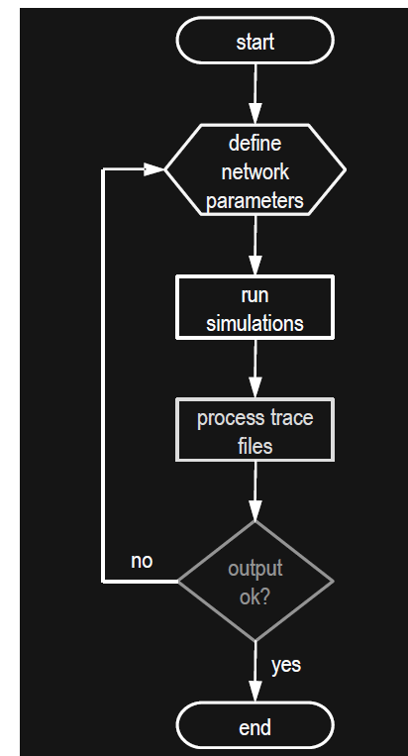

2. LAB REQUIREMENTS

H/W Detail

Intel i3/C2D Processor/2 GB RAM/500GB HDD/MB/Lan Card/
Key Board/ Mouse/CD Drive/15” Color Monitor/ UPS

24 Nos.

LaserJet Printer 1 No.

S/W Detail Ubunto, Fedora Linux, NS3

3. List of experiments
NETWORK SIMULATION LAB
III B. TECH- II SEMESTER
Course Code | Category | Hours / Week |  |  | Credits | Maximum Marks
A4CS17 | PCC | L | T | P | C | CIE | SEE | Total
A4CS17 | PCC | - | - | 3 | 1.5 | 30 | 70 | 100
COURSE OVERVIEW:
The course is designed for the students to develop their network simulation skills using NS3. It will help the students to work with their networking and research projects.

COURSE OBJECTIVES:
- Understand the importance and usage of NS3
- To inclulcate working knowledge among Node to Node communication in networks.
- Understand and implement various networking topology.
- To familianize with the Net Anim

COURSE OUTCOMES:
By the end of this course, the student will be able to
- Install NS3 and its supporting packages.
- Implement connecting various nodes
- Implement Star and bus and Hybrid topologies using NS3
- Use and develop applications using NetAnim.
SYLLABUS
EXPERIMENTS:
- Introduction about discrete events simulation and its tools.
- Installation of NS3 in Linux Operating System.
- Program in NS3 to connect two nodes.
- Program in NS3 for connecting three nodes considering one node as a central node.
- Implement physical star topology and simulate using NS3.
- Implement physical bus topology and simulate using NS3.
- Program for connecting multiple routers and nodes and building a hybrid topology.
- Installation and configuration of NetAnim
- Program in NS3 to implement FTP using TCP bulk transfer.
- Implement AODV Routing Protocol
- Implement DSDV Routing Protocol.
- Implement DSR Routing Protocol.
TEXT BOOKS:
- Andrew S Tanenbaum David J Wetherall , Computer Networks, 5th Edition, Pearson Education.
- Kurose, Ross (2010), Computer Networking: A top down approach, Sixth Edition, Pearson Education, India.
REFERENCES:
- Behrouz A. Forouzan, Data communication and Networking, 4th Edition, Mc Graw-Hill, India.
- Larry L. Peterson, ‎Bruce S. Davie, Computer Networks: A Systems Approach, MK Publishers
WEB LINKS:
- https://www.nsnam.org/releases/
- https://www.nsnam.org/documentation/

EXPERIMENT 1: Introduction to Discrete-Event Simulation and its tools.
System:
A collection of entities that act and interact together toward the accomplishment of some logical end.
Discrete system:
State variables change instantaneously at separated point in time, e.g., a bank, since state variables - number of customers, change only when a customer arrives or when a customer finishes being served and departs.
Continuous system:
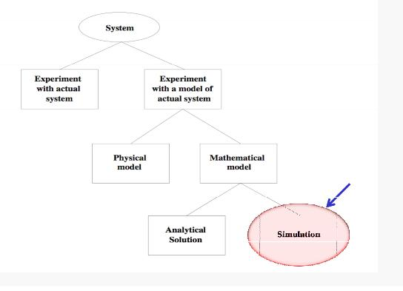
State variable change continuously with respect to time, e.g., airplane moving through the air, since state variables - position and velocity change continuously with respect to time .

Fig 1: Ways to study the system

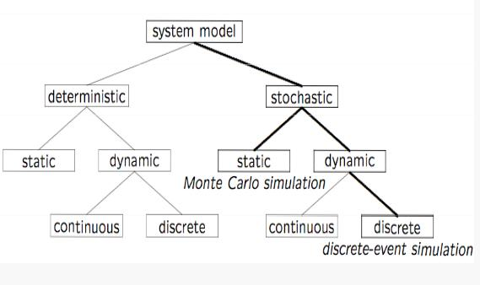
Fig 2: Model Taxonomy

Why Simulation?
• Many systems are highly complex, precluding the possibility of analytical solution
•The analytical solutions are extraordinarily complex, requiring vast computing resources
•Thus, such systems should be studied by means of simulation
numerically exercising the model for inputs in question to see how they affect the output measures of performance
“Simulationis the process of designinga model of a real system and conductingexperimentswith this model for the purpose eitherof understandingthe behavior of the system or of evaluatingvarious strategies(within the limits imposed by a criterion or set of criteria) for theoperationof a system.”
What is Discrete-Event Simulation (DES)
A discrete-event simulation models a system whose state may change only at discrete point models a system whose state may change only at discrete point in time
System:
System is composed of objects called entities that have certain properties called attributes.
State:
State is a collection of attributes or state variables that represent the entities of the system.
Event:
Event is an instantaneous occurrence in time that may alter the state of the system
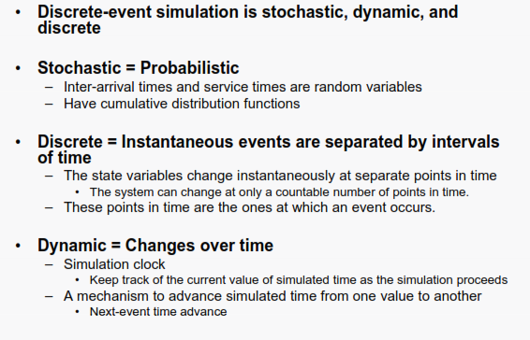
Fig 3: Introduction to Discrete Event Simulation

EXPERIMENT 2:

Installation of NS3 in Linux Operating System.

Following are the basic steps which must be followed for installing NS3
1. Install prerequisite packages
2. Download ns3 codes
3. Build ns3
4. Validate ns3

Step1:

$sudo apt update

Step2:

$sudo apt install build-essential autoconf automake libxmu-dev python3-pygraphviz cvs mercurial bzr git cmake p7zip-full python3-matplotlib python-tk python3-dev qt5-qmake qt5-default gnuplot-x11 wireshark

Step3:
Download ns3 version from nsnam.org

$tar jxvf ns-allinone-3.32.tar.bz2
$ cd ns-allinone-3.32/
$ ./build.py --enable-examples --enable-tests

Step4:
$] cd ns-3.32/
$] ./waf --run hello-simulator

For Netanim Steps

$] sudo apt-get update
$] sudo apt-get install qt4-dev-tools qt4-qmake, qt4-qmake qt4-default
$] cd ns-allinone-3.24.1/netanim-3.106/
$] make clean
$] make
$] qmake NetAnim.pro

$] ./NetAnim file.xml

EXPERIMENT 3:
Program in NS3 to connect two nodes.

/* -*- Mode:C++; c-file-style:"gnu"; indent-tabs-mode:nil; -*- */
/*
* This program is free software; you can redistribute it and/or modify
* it under the terms of the GNU General Public License version 2 as
* published by the Free Software Foundation;
*
* This program is distributed in the hope that it will be useful,
* but WITHOUT ANY WARRANTY; without even the implied warranty of
* MERCHANTABILITY or FITNESS FOR A PARTICULAR PURPOSE. See the
* GNU General Public License for more details.
*
* You should have received a copy of the GNU General Public License
* along with this program; if not, write to the Free Software
* Foundation, Inc., 59 Temple Place, Suite 330, Boston, MA 02111-1307 USA
*/

#include "ns3/core-module.h"
#include "ns3/network-module.h"
#include "ns3/internet-module.h"
#include "ns3/point-to-point-module.h"
#include "ns3/applications-module.h"
#include “ns3/netanim-module.h”

// Default Network Topology
//
// 10.1.1.0
// n0 -------------- n1
// point-to-point
//

using namespace ns3;

NS_LOG_COMPONENT_DEFINE ("FirstScriptExample");

int
main (int argc, char *argv[])
{
CommandLine cmd (__FILE__);
cmd.Parse (argc, argv);

Time::SetResolution (Time::NS);
LogComponentEnable ("UdpEchoClientApplication", LOG_LEVEL_INFO);
LogComponentEnable ("UdpEchoServerApplication", LOG_LEVEL_INFO);

NodeContainer nodes;
nodes.Create (2);

PointToPointHelper pointToPoint;
pointToPoint.SetDeviceAttribute ("DataRate", StringValue ("5Mbps"));
pointToPoint.SetChannelAttribute ("Delay", StringValue ("2ms"));

NetDeviceContainer devices;
devices = pointToPoint.Install (nodes);

InternetStackHelper stack;
stack.Install (nodes);

Ipv4AddressHelper address;
address.SetBase ("10.1.1.0", "255.255.255.0");

Ipv4InterfaceContainer interfaces = address.Assign (devices);

UdpEchoServerHelper echoServer (9);

ApplicationContainer serverApps = echoServer.Install (nodes.Get (1));
serverApps.Start (Seconds (1.0));
serverApps.Stop (Seconds (10.0));

UdpEchoClientHelper echoClient (interfaces.GetAddress (1), 9);
echoClient.SetAttribute ("MaxPackets", UintegerValue (1));
echoClient.SetAttribute ("Interval", TimeValue (Seconds (1.0)));
echoClient.SetAttribute ("PacketSize", UintegerValue (1024));

ApplicationContainer clientApps = echoClient.Install (nodes.Get (0));
clientApps.Start (Seconds (2.0));
clientApps.Stop (Seconds (10.0));

AnimationInterface anim(“first.xml”);
anim.SetConstantPosition(nodes.Get(0),10.0,10.0);
anim.SetConstantPosition(nodes.Get(1),40.0,40.0);

Simulator::Run ();
Simulator::Destroy ();
return 0;
}

STEPS FOR EXECUTION

Step1:
$ cd Desktop/ns-allinone-3.32/ns-3.32/

Step2: Which helps to compile the program and generate the xml file as defined in program in our program it is “first.xml”
$ ./waf --run scratch/first

Step3: To plot using NetAnim

$ cd ..
$ cd netanim-3.108
$ ./Netanim

Then link to the file folder where the xml file is stored within NetAnim :/ns-allinone-3.32/ns-3.32/
select xml file and after that select play button we will the movement data packets from point to point(node0 to node1)

Here are the screen shots
Screenshot1
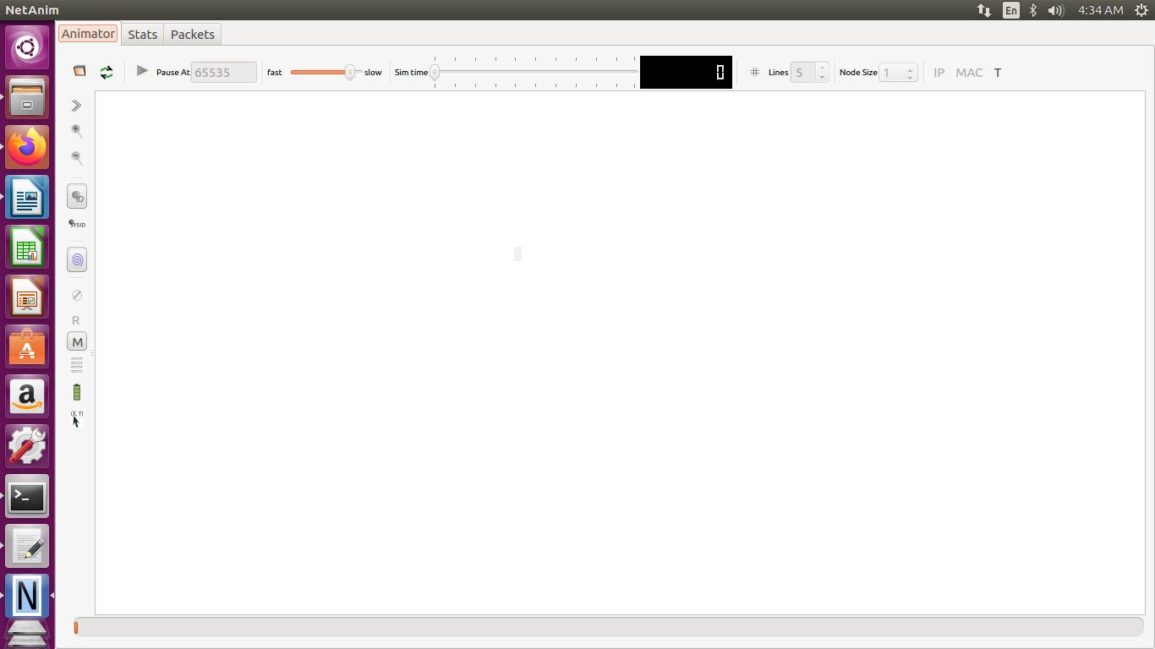

Screenshot2

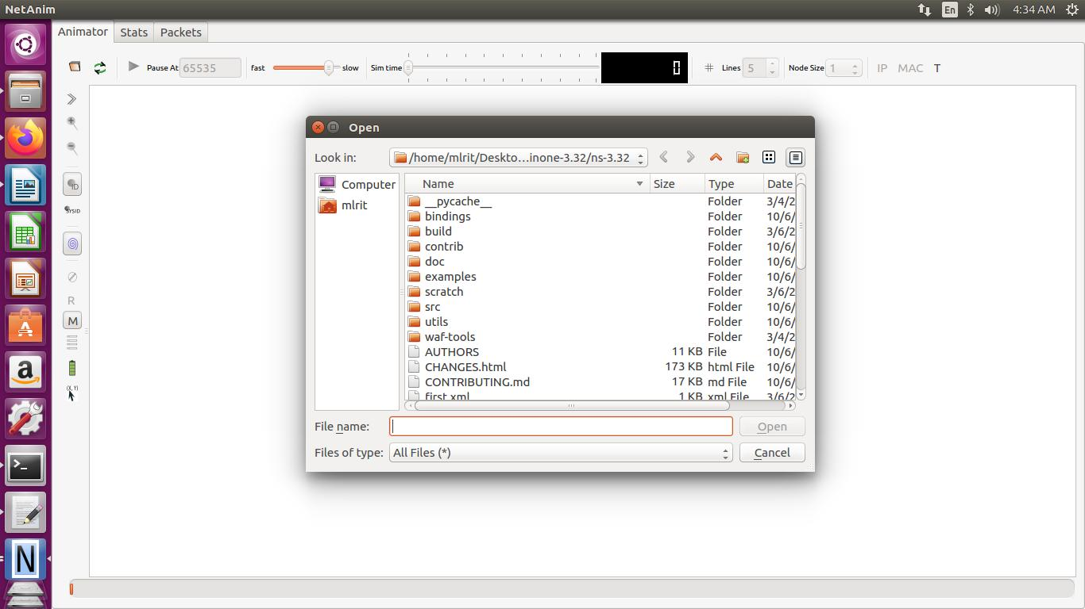

Screenshot3
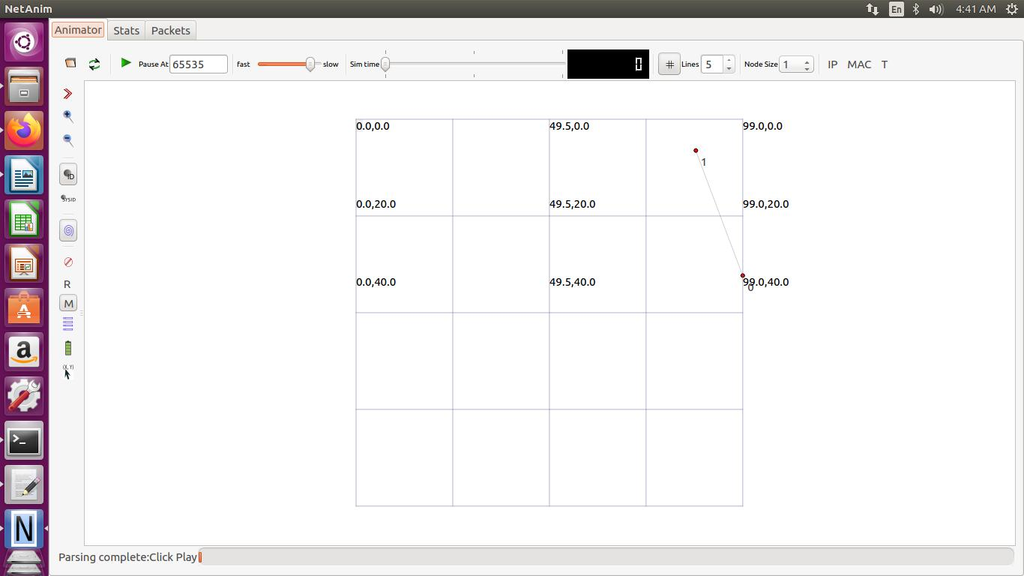

Screenshot4
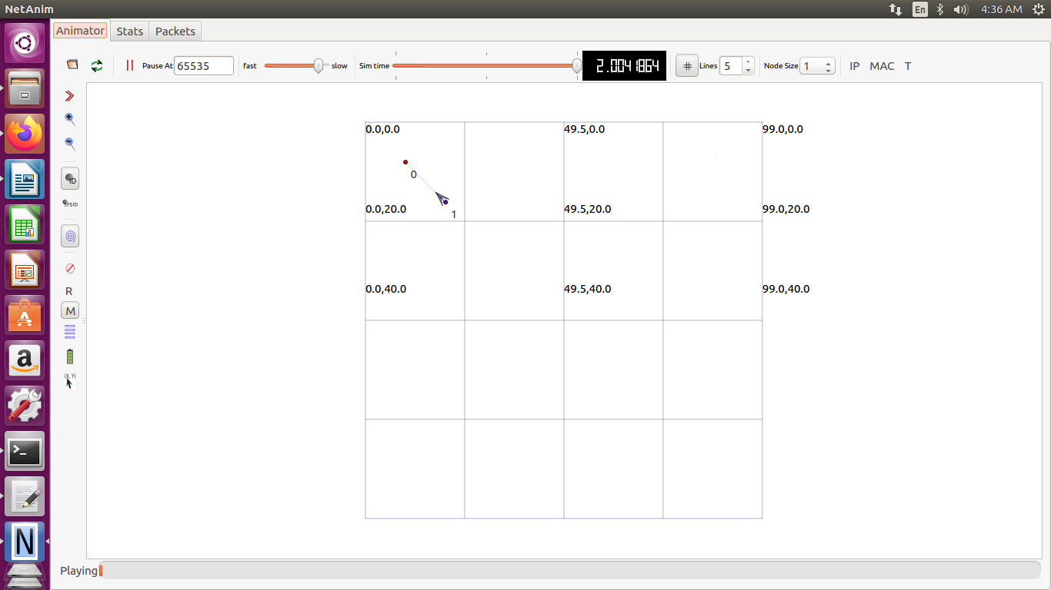

EXPERIMENT 4:
Program in NS3 for connecting three nodes considering one node as a central node.

/* -*- Mode:C++; c-file-style:"gnu"; indent-tabs-mode:nil; -*- */
/*
* This program is free software; you can redistribute it and/or modify
* it under the terms of the GNU General Public License version 2 as
* published by the Free Software Foundation;
*
* This program is distributed in the hope that it will be useful,
* but WITHOUT ANY WARRANTY; without even the implied warranty of
* MERCHANTABILITY or FITNESS FOR A PARTICULAR PURPOSE. See the
* GNU General Public License for more details.
*
* You should have received a copy of the GNU General Public License
* along with this program; if not, write to the Free Software
* Foundation, Inc., 59 Temple Place, Suite 330, Boston, MA 02111-1307 USA
*/

#include "ns3/core-module.h"
#include "ns3/network-module.h"
#include "ns3/internet-module.h"
#include "ns3/point-to-point-module.h"
#include "ns3/applications-module.h"
#include "ns3/netanim-module.h"

// Default Network Topology
//
// 10.1.1.0
// n0 -------------- n1------------n3 with any one being a central node
// point-to-point
//

using namespace ns3;

NS_LOG_COMPONENT_DEFINE ("FirstScriptExample");

int
main (int argc, char *argv[])
{
CommandLine cmd (__FILE__);
cmd.Parse (argc, argv);

Time::SetResolution (Time::NS);
LogComponentEnable ("UdpEchoClientApplication", LOG_LEVEL_INFO);
LogComponentEnable ("UdpEchoServerApplication", LOG_LEVEL_INFO);

NodeContainer nodes;
nodes.Create (3);

PointToPointHelper pointToPoint;
pointToPoint.SetDeviceAttribute ("DataRate", StringValue ("5Mbps"));
pointToPoint.SetChannelAttribute ("Delay", StringValue ("2ms"));

NetDeviceContainer devices;
devices = pointToPoint.Install(nodes.Get(0),nodes.Get(1));
NetDeviceContainer devices1;
devices1 = pointToPoint.Install(nodes.Get(2),nodes.Get(1));

InternetStackHelper stack;
stack.Install (nodes);

Ipv4AddressHelper address;
address.SetBase ("10.1.1.0", "255.255.255.0");
Ipv4AddressHelper address1;
address1.SetBase ("198.168.1.0", "255.255.255.0");

Ipv4InterfaceContainer interfaces = address.Assign (devices);
Ipv4InterfaceContainer interfaces1 = address.Assign (devices1);

UdpEchoServerHelper echoServer (90);
UdpEchoServerHelper echoServer1 (91);

ApplicationContainer serverApps = echoServer.Install (nodes.Get (1));
serverApps.Start (Seconds (1.0));
serverApps.Stop (Seconds (10.0));

UdpEchoClientHelper echoClient (interfaces.GetAddress (1), 90);
echoClient.SetAttribute ("MaxPackets", UintegerValue (1));
echoClient.SetAttribute ("Interval", TimeValue (Seconds (1.0)));
echoClient.SetAttribute ("PacketSize", UintegerValue (1048));

UdpEchoClientHelper echoClient1 (interfaces.GetAddress (1), 91);
echoClient.SetAttribute ("MaxPackets", UintegerValue (1));
echoClient.SetAttribute ("Interval", TimeValue (Seconds (1.0)));
echoClient.SetAttribute ("PacketSize", UintegerValue (1048));

ApplicationContainer clientApps = echoClient.Install (nodes.Get (0));
clientApps.Start (Seconds (2.0));
clientApps.Stop (Seconds (5.0));

ApplicationContainer clientApps1 = echoClient1.Install (nodes.Get (2));
clientApps.Start (Seconds (7.0));
clientApps.Stop (Seconds (10.0));

AnimationInterface anim("s.xml");
anim.SetConstantPosition(nodes.Get(0),10.0,10.0);
anim.SetConstantPosition(nodes.Get(1),20.0,20.0);
anim.SetConstantPosition(nodes.Get(2),30.0,30.0);

Simulator::Run ();
Simulator::Destroy ();
return 0;
}

Steps :As Same as Previous Program

Screenshots

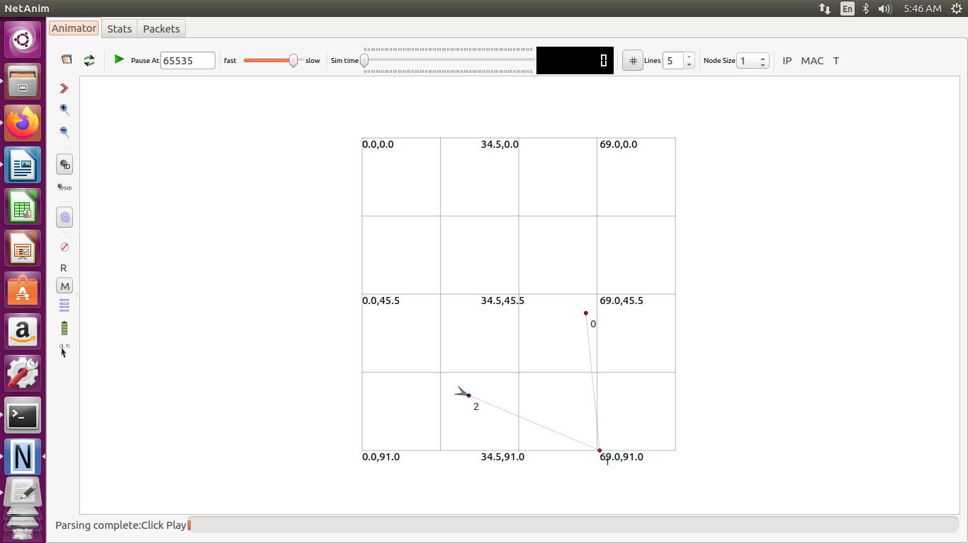

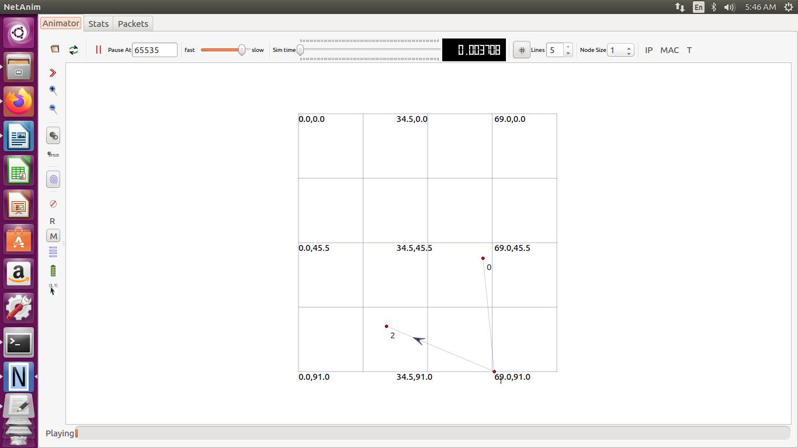

EXPERIMENT 5:
Implement physical star topology and simulate using NS3.

/* -*- Mode:C++; c-file-style:"gnu"; indent-tabs-mode:nil; -*- */
/*
* This program is free software; you can redistribute it and/or modify
* it under the terms of the GNU General Public License version 2 as
* published by the Free Software Foundation;
*
* This program is distributed in the hope that it will be useful,
* but WITHOUT ANY WARRANTY; without even the implied warranty of
* MERCHANTABILITY or FITNESS FOR A PARTICULAR PURPOSE. See the
* GNU General Public License for more details.
*
* You should have received a copy of the GNU General Public License
* along with this program; if not, write to the Free Software
* Foundation, Inc., 59 Temple Place, Suite 330, Boston, MA 02111-1307 USA
*
*/

#include "ns3/core-module.h"
#include "ns3/network-module.h"
#include "ns3/netanim-module.h"
#include "ns3/internet-module.h"
#include "ns3/point-to-point-module.h"
#include "ns3/applications-module.h"
#include "ns3/point-to-point-layout-module.h"

// Network topology (default)
//
// n2 n3 n4 .
// \ | / .
// \|/ .
// n1--- n0---n5 .
// /|\ .
// / | \ .
// n8 n7 n6 .
//

using namespace ns3;

NS_LOG_COMPONENT_DEFINE ("StarAnimation");

int
main (int argc, char *argv[])
{

//
// Set up some default values for the simulation.
//
Config::SetDefault ("ns3::OnOffApplication::PacketSize", UintegerValue (137));

// ??? try and stick 15kb/s into the data rate
Config::SetDefault ("ns3::OnOffApplication::DataRate", StringValue ("14kb/s"));

//
// Default number of nodes in the star. Overridable by command line argument.
//
uint32_t nSpokes = 8;
std::string animFile = "star-animation.xml";
uint8_t useIpv6 = 0;
Ipv6Address ipv6AddressBase = Ipv6Address("2001::");
Ipv6Prefix ipv6AddressPrefix = Ipv6Prefix(64);

CommandLine cmd;
cmd.AddValue ("nSpokes", "Number of spoke nodes to place in the star", nSpokes);
cmd.AddValue ("animFile", "File Name for Animation Output", animFile);
cmd.AddValue ("useIpv6", "use Ipv6", useIpv6);

cmd.Parse (argc, argv);

NS_LOG_INFO ("Build star topology.");
PointToPointHelper pointToPoint;
pointToPoint.SetDeviceAttribute ("DataRate", StringValue ("5Mbps"));
pointToPoint.SetChannelAttribute ("Delay", StringValue ("2ms"));
PointToPointStarHelper star (nSpokes, pointToPoint);

NS_LOG_INFO ("Install internet stack on all nodes.");
InternetStackHelper internet;
star.InstallStack (internet);

NS_LOG_INFO ("Assign IP Addresses.");
if (useIpv6 == 0)
{
star.AssignIpv4Addresses (Ipv4AddressHelper ("10.1.1.0", "255.255.255.0"));
}
else
{
star.AssignIpv6Addresses (ipv6AddressBase, ipv6AddressPrefix);
}

NS_LOG_INFO ("Create applications.");
//
// Create a packet sink on the star "hub" to receive packets.
//
uint16_t port = 50000;
Address hubLocalAddress;
if (useIpv6 == 0)
{
hubLocalAddress = InetSocketAddress (Ipv4Address::GetAny (), port);
}
else
{
hubLocalAddress = Inet6SocketAddress (Ipv6Address::GetAny (), port);
}
PacketSinkHelper packetSinkHelper ("ns3::TcpSocketFactory", hubLocalAddress);
ApplicationContainer hubApp = packetSinkHelper.Install (star.GetHub ());
hubApp.Start (Seconds (1.0));
hubApp.Stop (Seconds (10.0));

//
// Create OnOff applications to send TCP to the hub, one on each spoke node.
//
OnOffHelper onOffHelper ("ns3::TcpSocketFactory", Address ());
onOffHelper.SetAttribute ("OnTime", StringValue ("ns3::ConstantRandomVariable[Constant=1]"));
onOffHelper.SetAttribute ("OffTime", StringValue ("ns3::ConstantRandomVariable[Constant=0]"));

ApplicationContainer spokeApps;

for (uint32_t i = 0; i < star.SpokeCount (); ++i)
{
AddressValue remoteAddress;
if (useIpv6 == 0)
{
remoteAddress = AddressValue(InetSocketAddress (star.GetHubIpv4Address (i), port));
}
else
{
remoteAddress = AddressValue(Inet6SocketAddress (star.GetHubIpv6Address (i), port));
}
onOffHelper.SetAttribute ("Remote", remoteAddress);
spokeApps.Add (onOffHelper.Install (star.GetSpokeNode (i)));
}
spokeApps.Start (Seconds (1.0));
spokeApps.Stop (Seconds (10.0));

NS_LOG_INFO ("Enable static global routing.");
//
// Turn on global static routing so we can actually be routed across the star.
//
if (useIpv6 == 0)
{
Ipv4GlobalRoutingHelper::PopulateRoutingTables ();
}

// Set the bounding box for animation
star.BoundingBox (1, 1, 100, 100);

// Create the animation object and configure for specified output
AnimationInterface anim ("star-animation.xml");

NS_LOG_INFO ("Run Simulation.");
Simulator::Run ();
Simulator::Destroy ();
NS_LOG_INFO ("Done.");

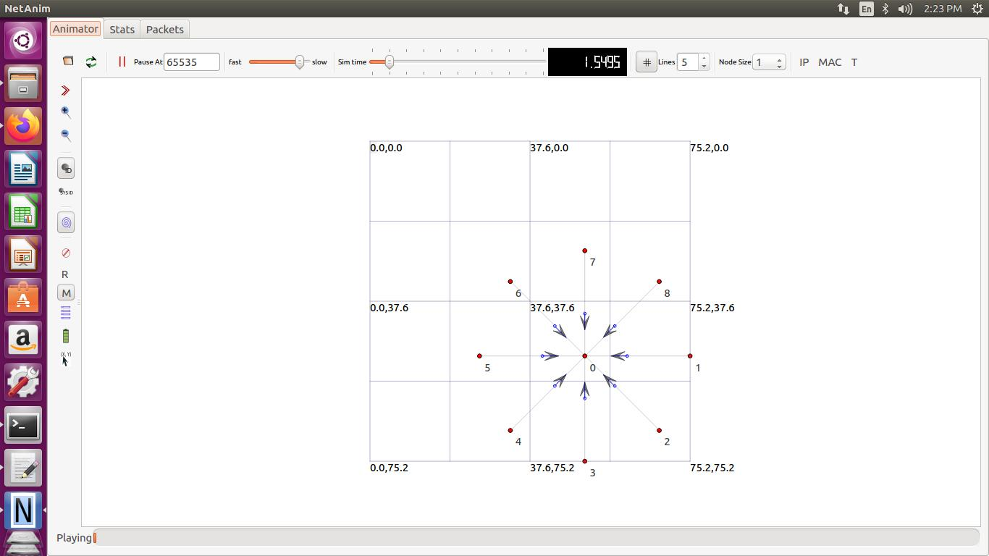
return 0;
}

EXPERIMENT 6:
Implement physical bus topology and simulate using NS3.

/* -*- Mode:C++; c-file-style:"gnu"; indent-tabs-mode:nil; -*- */
/*
* This program is free software; you can redistribute it and/or modify
* it under the terms of the GNU General Public License version 2 as
* published by the Free Software Foundation;
*
* This program is distributed in the hope that it will be useful,
* but WITHOUT ANY WARRANTY; without even the implied warranty of
* MERCHANTABILITY or FITNESS FOR A PARTICULAR PURPOSE. See the
* GNU General Public License for more details.
*
* You should have received a copy of the GNU General Public License
* along with this program; if not, write to the Free Software
* Foundation, Inc., 59 Temple Place, Suite 330, Boston, MA 02111-1307 USA
*/

#include "ns3/core-module.h"
#include "ns3/network-module.h"
#include "ns3/csma-module.h"
#include "ns3/internet-module.h"
#include "ns3/point-to-point-module.h"
#include "ns3/applications-module.h"
#include "ns3/ipv4-global-routing-helper.h"
#include "ns3/netanim-module.h"

// Default Network Topology (BUS TOPOLOGY)
//
// 10.1.1.0
// n0 -------------- n1 n2 n3 n4
// point-to-point | | | |
// ================
// LAN 10.1.2.0

using namespace ns3;

NS_LOG_COMPONENT_DEFINE ("SecondScriptExample");

int
main (int argc, char *argv[])
{
bool verbose = true;
uint32_t nCsma = 3;

CommandLine cmd (__FILE__);
cmd.AddValue ("nCsma", "Number of \"extra\" CSMA nodes/devices", nCsma);
cmd.AddValue ("verbose", "Tell echo applications to log if true", verbose);

cmd.Parse (argc,argv);

if (verbose)
{
LogComponentEnable ("UdpEchoClientApplication", LOG_LEVEL_INFO);
LogComponentEnable ("UdpEchoServerApplication", LOG_LEVEL_INFO);
}

nCsma = nCsma == 0 ? 1 : nCsma;

NodeContainer p2pNodes;
p2pNodes.Create (2);

NodeContainer csmaNodes;
csmaNodes.Add (p2pNodes.Get (1));
csmaNodes.Create (nCsma);

PointToPointHelper pointToPoint;
pointToPoint.SetDeviceAttribute ("DataRate", StringValue ("5Mbps"));
pointToPoint.SetChannelAttribute ("Delay", StringValue ("2ms"));

NetDeviceContainer p2pDevices;
p2pDevices = pointToPoint.Install (p2pNodes);

CsmaHelper csma;
csma.SetChannelAttribute ("DataRate", StringValue ("100Mbps"));
csma.SetChannelAttribute ("Delay", TimeValue (NanoSeconds (6560)));

NetDeviceContainer csmaDevices;
csmaDevices = csma.Install (csmaNodes);

InternetStackHelper stack;
stack.Install (p2pNodes.Get (0));
stack.Install (csmaNodes);

Ipv4AddressHelper address;
address.SetBase ("10.1.1.0", "255.255.255.0");
Ipv4InterfaceContainer p2pInterfaces;
p2pInterfaces = address.Assign (p2pDevices);

address.SetBase ("10.1.2.0", "255.255.255.0");
Ipv4InterfaceContainer csmaInterfaces;
csmaInterfaces = address.Assign (csmaDevices);

UdpEchoServerHelper echoServer (9);

ApplicationContainer serverApps = echoServer.Install (csmaNodes.Get (nCsma));
serverApps.Start (Seconds (1.0));
serverApps.Stop (Seconds (10.0));

UdpEchoClientHelper echoClient (csmaInterfaces.GetAddress (nCsma), 9);
echoClient.SetAttribute ("MaxPackets", UintegerValue (1));
echoClient.SetAttribute ("Interval", TimeValue (Seconds (1.0)));
echoClient.SetAttribute ("PacketSize", UintegerValue (1024));

ApplicationContainer clientApps = echoClient.Install (p2pNodes.Get (0));
clientApps.Start (Seconds (2.0));
clientApps.Stop (Seconds (10.0));

Ipv4GlobalRoutingHelper::PopulateRoutingTables ();

pointToPoint.EnablePcapAll ("p2p");
csma.EnablePcap ("csma1", csmaDevices.Get (1), true);
csma.EnablePcap ("csma3", csmaDevices.Get (3), true);

AnimationInterface anim("bus.xml");
anim.SetConstantPosition(p2pNodes.Get(0),10.0,10.0);
anim.SetConstantPosition(csmaNodes.Get(0),20.0,20.0);
anim.SetConstantPosition(csmaNodes.Get(1),30.0,30.0);
anim.SetConstantPosition(csmaNodes.Get(2),40.0,40.0);
anim.SetConstantPosition(csmaNodes.Get(3),50.0,50.0);

Simulator::Run ();
Simulator::Destroy ();
return 0;
}

Screenshot:

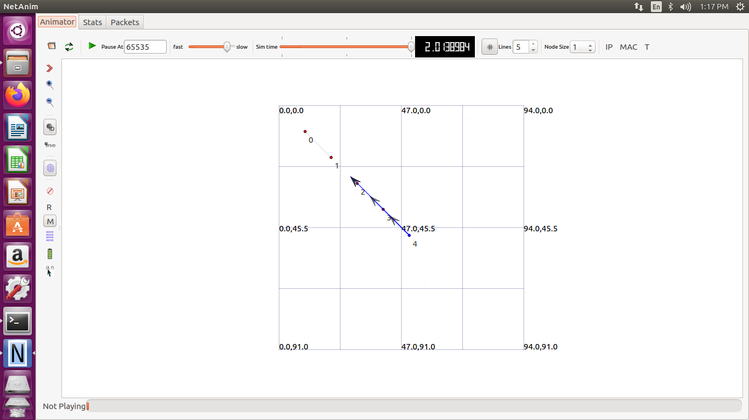

EXPERIMENT 7: Providing Multiple Routers and Nodes and building a Hybrid Topology

#include "ns3/core-module.h"
#include "ns3/network-module.h"
#include "ns3/csma-module.h"
#include "ns3/internet-module.h"
#include "ns3/point-to-point-module.h"
#include "ns3/applications-module.h"
#include "ns3/ipv4-global-routing-helper.h"
#include "ns3/netanim-module.h"
// Default Network Hybrid Topology 10.1.5.0
// r2---------n1
// / 10.1.3.0
// no----------r0--------r1
// 10.1.1.0 10.1.2.0 \ 10.1.4.0
// r3
using namespace ns3;
NS_LOG_COMPONENT_DEFINE ("SecondScriptExample");
int
main (int argc, char *argv[])
{
bool verbose = true;
if (verbose)
{
LogComponentEnable ("UdpEchoClientApplication", LOG_LEVEL_INFO);
LogComponentEnable ("UdpEchoServerApplication", LOG_LEVEL_INFO);
}
NodeContainer host, router, host1;
host.Create (2);
router.Create (4);

NodeContainer subnet1;
subnet1.Add (host.Get (0));
subnet1.Add (router.Get (0));

PointToPointHelper pointToPoint;
pointToPoint.SetDeviceAttribute ("DataRate", StringValue ("5Mbps"));
pointToPoint.SetChannelAttribute ("Delay", StringValue ("2ms"));
NetDeviceContainer subnet1Devices;
subnet1Devices = pointToPoint.Install (subnet1);
InternetStackHelper stack;
stack.Install (router);
stack.Install (host);

Ipv4AddressHelper address1, address2, address3, address4, address5, address6,;
Address1.SetBase ("10.1.1.0", "255.255.255.0");
Ipv4InterfaceContainer subnet1Interfaces;
subnet1Interfaces = address1.Assign (subnet1Devices);
NodeContainer subnet2;
subnet2.Add (router.Get (0));
subnet2.Add (router.Get (1));
NetDeviceContainer subnet2Devices;
subnet2Devices = pointToPoint.Install (subnet2);

address2.SetBase ("10.1.2.0", "255.255.255.0");
Ipv4InterfaceContainer subnet2Interfaces;
subnet2Interfaces = address2.Assign (subnet2Devices);
NodeContainer subnet3;
subnet3.Add (router.Get (1));
subnet3.Add (router.Get (2));
NetDeviceContainer subnet3Devices;
subnet3Devices = pointToPoint.Install (subnet3);

address3.SetBase ("10.1.3.0", "255.255.255.0");
Ipv4InterfaceContainer subnet3Interfaces;
subnet3Interfaces = address3.Assign (subnet3Devices);
NodeContainer subnet4;
subnet4.Add (router.Get (1));
subnet4.Add (router.Get (3));
NetDeviceContainer subnet4Devices;
subnet4Devices = pointToPoint.Install (subnet4);

address4.SetBase ("10.1.4.0", "255.255.255.0");
Ipv4InterfaceContainer subnet4Interfaces;
subnet4Interfaces = address4.Assign (subnet4Devices);
NodeContainer subnet5;
subnet5.Add (router.Get (2));
subnet5.Add (host.Get (1));
NetDeviceContainer subnet5Devices;
subnet5Devices = pointToPoint.Install (subnet5);

address5.SetBase ("10.1.5.0", "255.255.255.0");
Ipv4InterfaceContainer subnet5Interfaces;
subnet5Interfaces = address5.Assign (subnet5Devices);
UdpEchoServerHelper echoServer (9);
ApplicationContainer serverApps = echoServer.Install (subnet5.Get (1));
serverApps.Start (Seconds (1.0));
serverApps.Stop (Seconds (10.0));
UdpEchoClientHelper echoClient (subnet5Interfaces.GetAddress (1), 9);
echoClient.SetAttribute ("MaxPackets", UintegerValue (3));
echoClient.SetAttribute ("Interval", TimeValue (Seconds (1.0)));
echoClient.SetAttribute ("PacketSize", UintegerValue (1024));
ApplicationContainer clientApps = echoClient.Install (subnet1.Get (0));
clientApps.Start (Seconds (1.0));
clientApps.Stop (Seconds (10.0));
Ipv4GlobalRoutingHelper::PopulateRoutingTables ();
AnimationInterface anim(“hybrid.xml”);
Simulator::Run ();
Simulator::Destroy ();
return 0;
}

EXPERIMENT8:Installation and Configuration of NETANIM

Installing NetAnim The website: http://www.nsnam.org/wiki/index.php/NetAnim

1. Install Mercurial: apt−get/dnf install mercurial
2. Install QT4 development package: apt−get/dnf install qt4−dev−tools
3. You can use Synaptic too, to install both the above packages.
4. Download NetAnim: hg clone http :// code .nsnam. org/netanim
5. Build NetAnim: cd netanim make clean qmake NetAnim. pro make
Compiling code with NetAnim

So will have to make the following changes to the code, in order to view the animation on NetAnim.
#include " ... " #include "ns3/netanim−module .h"
//1Include. . . int main ( int argc , char ∗argv [ ] ) { std : : string animFile = "somename. xml";
//2 Name of f i l e for animation . . . AnimationInterface anim ( animFile );
//3 Animation interface Simulator : : Run (); Simulator : : Destroy (); return 0; }

To run the code:
1. Move the waf , waf.bat , wscript and wutils.py les in to the scratch folder (~/ns-allinone-3.24/ns-3.24/scratch/).
2. Move the example code to the scratch folder and make the changes required for NetAnim, as shown above.
3. Now cd to the scratch folder (cd ~/ns-allinone-3.24/ns-3.24/scratch/).
4. Run the code using the command: ./ waf −−run Note: < lename> should not contain the extension .cc

To visualize on NetAnim:
1. cd to the netanim folder (cd ~/netanim/).
2. Run Netanim: ./NetAnim
3. Include the .xml le generated in the ns-3.24 folder (~/ns-allinone3.17/ns3.24/).

EXPERIMENT 9:
Program in NS3 to implement FTP using TCP bulk transfer.

/* -*- Mode:C++; c-file-style:"gnu"; indent-tabs-mode:nil; -*- */
/*
* This program is free software; you can redistribute it and/or modify
* it under the terms of the GNU General Public License version 2 as
* published by the Free Software Foundation;
*
* This program is distributed in the hope that it will be useful,
* but WITHOUT ANY WARRANTY; without even the implied warranty of
* MERCHANTABILITY or FITNESS FOR A PARTICULAR PURPOSE. See the
* GNU General Public License for more details.
*
* You should have received a copy of the GNU General Public License
* along with this program; if not, write to the Free Software
* Foundation, Inc., 59 Temple Place, Suite 330, Boston, MA 02111-1307 USA
*/

// Network topology
//
// n0 ----------- n1
// 500 Kbps
// 5 ms
//
// - Flow from n0 to n1 using BulkSendApplication.
// - Tracing of queues and packet receptions to file "tcp-bulk-send.tr"
// and pcap tracing available when tracing is turned on.

#include <string>
#include <fstream>
#include "ns3/core-module.h"
#include "ns3/point-to-point-module.h"
#include "ns3/internet-module.h"
#include "ns3/applications-module.h"
#include "ns3/network-module.h"
#include "ns3/packet-sink.h"

using namespace ns3;

NS_LOG_COMPONENT_DEFINE ("TcpBulkSendExample");

int
main (int argc, char *argv[])
{
//make boolean value of tracing as true
bool tracing = true;
uint32_t maxBytes = 0;

//
// Allow the user to override any of the defaults at
// run-time, via command-line arguments
//
CommandLine cmd (__FILE__);
cmd.AddValue ("tracing", "Flag to enable/disable tracing", tracing);
cmd.AddValue ("maxBytes",
"Total number of bytes for application to send", maxBytes);
cmd.Parse (argc, argv);

//
// Explicitly create the nodes required by the topology (shown above).
//
NS_LOG_INFO ("Create nodes.");
NodeContainer nodes;
nodes.Create (2);

NS_LOG_INFO ("Create channels.");

//
// Explicitly create the point-to-point link required by the topology (shown above).
//
PointToPointHelper pointToPoint;
pointToPoint.SetDeviceAttribute ("DataRate", StringValue ("500Kbps"));
pointToPoint.SetChannelAttribute ("Delay", StringValue ("5ms"));

NetDeviceContainer devices;
devices = pointToPoint.Install (nodes);

//
// Install the internet stack on the nodes
//
InternetStackHelper internet;
internet.Install (nodes);

//
// We've got the "hardware" in place. Now we need to add IP addresses.
//
NS_LOG_INFO ("Assign IP Addresses.");
Ipv4AddressHelper ipv4;
ipv4.SetBase ("10.1.1.0", "255.255.255.0");
Ipv4InterfaceContainer i = ipv4.Assign (devices);

NS_LOG_INFO ("Create Applications.");

//
// Create a BulkSendApplication and install it on node 0
//
uint16_t port = 9; // well-known echo port number

BulkSendHelper source ("ns3::TcpSocketFactory",
InetSocketAddress (i.GetAddress (1), port));
// Set the amount of data to send in bytes. Zero is unlimited.
source.SetAttribute ("MaxBytes", UintegerValue (maxBytes));
ApplicationContainer sourceApps = source.Install (nodes.Get (0));
sourceApps.Start (Seconds (0.0));
sourceApps.Stop (Seconds (10.0));

//
// Create a PacketSinkApplication and install it on node 1
//
PacketSinkHelper sink ("ns3::TcpSocketFactory",
InetSocketAddress (Ipv4Address::GetAny (), port));
ApplicationContainer sinkApps = sink.Install (nodes.Get (1));
sinkApps.Start (Seconds (0.0));
sinkApps.Stop (Seconds (10.0));

//
// Set up tracing if enabled
//Set up tracing boolean value as true
if (tracing)
{
AsciiTraceHelper ascii;
pointToPoint.EnableAsciiAll (ascii.CreateFileStream ("tcp-bulk-send.tr"));
pointToPoint.EnablePcapAll ("tcp-bulk-send", true);
}

//
// Now, do the actual simulation.
//
NS_LOG_INFO ("Run Simulation.");
Simulator::Stop (Seconds (10.0));
Simulator::Run ();
Simulator::Destroy ();
NS_LOG_INFO ("Done.");

Ptr<PacketSink> sink1 = DynamicCast<PacketSink> (sinkApps.Get (0));
std::cout << "Total Bytes Received: " << sink1->GetTotalRx () << std::endl;

}

Procepure of Execution

Step1: first run the code

./waf --run scratch/filename

Step2: After we run the above command we will generate the pcap file which is type of file used to capture the traffic flow in communication network using wireshark

Step3: To do above step type command ls

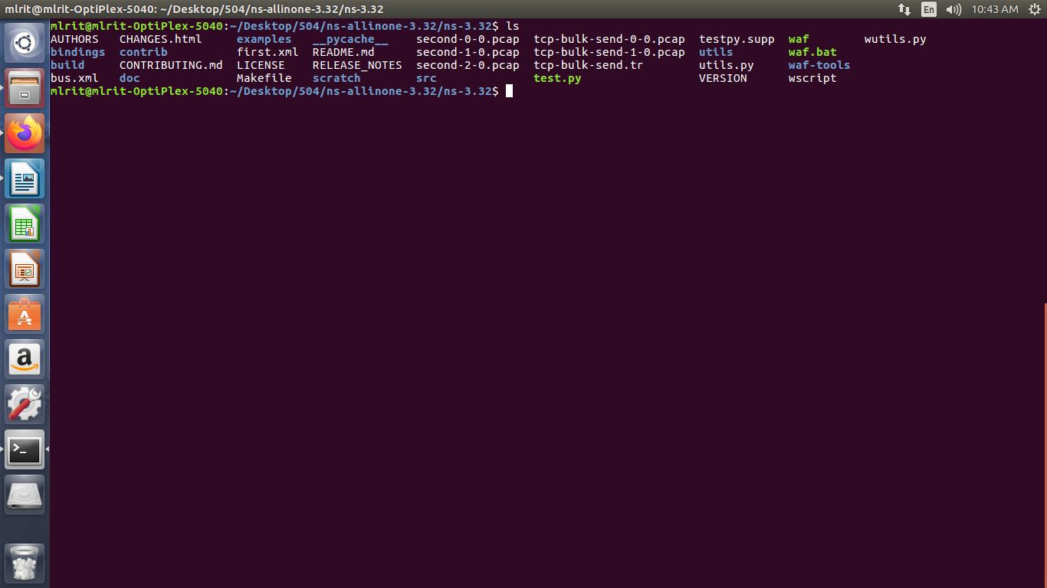

Step4: To know status of transfer of data from node0 type command as :

wireshark tcp-bulk-send-0-0.pcap

Then in wireshark console goto stastics and select I/O graph we know the trace graph for Node0 as shown in snapshot below

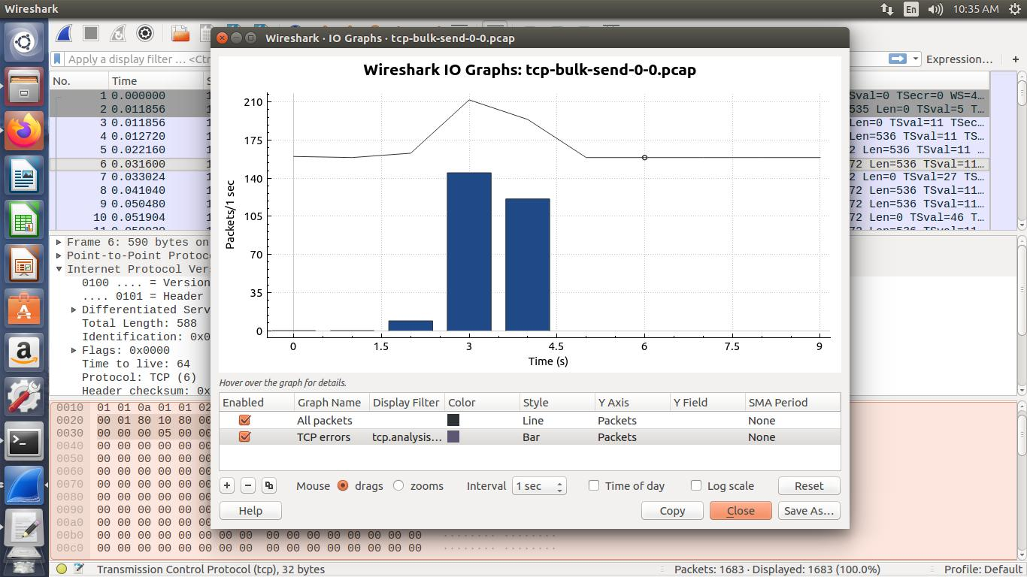

Step5:Similarly trace for node1

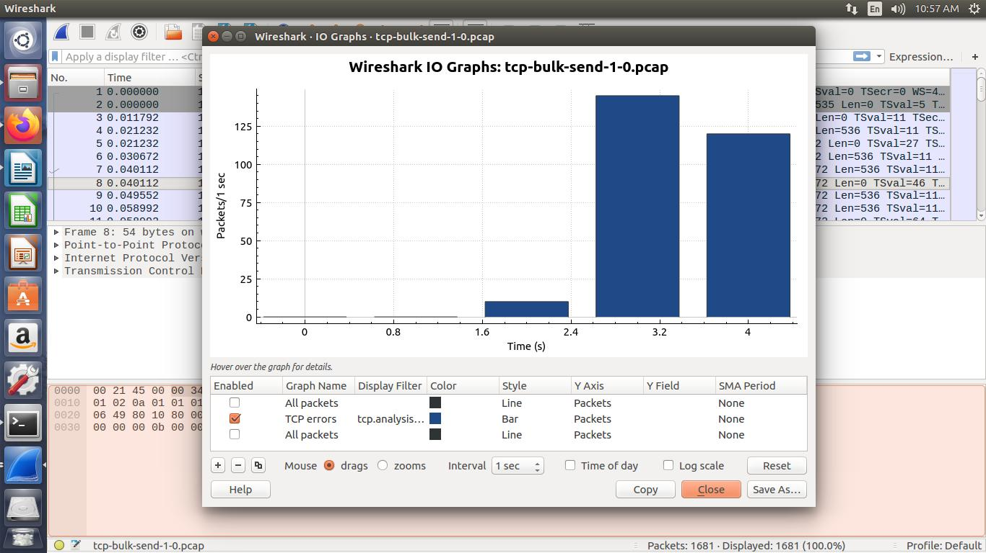

Also can run using this command for node0:
tcpdump -nn -tt -r tcp-bulk-send-0-0.pcap

similarly for node1:
ttcpdump -nn -tt -r tcp-bulk-send-1-0.pcap

EXPERIMENT10,11,12: Implementation of AODV Routing Protocol, DSDV Routing Protocol, AODV Routing Protocol

Program execution of last ThreeProgram:
Step1:
Go to Examples/Routing/
Copy manet-routing-compare.cc file and paste in scratch folder
Step2:
Then goto terminal
Type these commands to get CSVfiles for 1:OLSR,2-AODV,3-DSDV,4-DSR
./waf --run “scratch/manet-routing-compare --CSVfileName=OLSR --protocol=1”
The above command creates csv file for OLSR
Similarly do the same for AODV,DSDV and DSR as shown below
./waf --run “scratch/manet-routing-compare --CSVfileName=AODV --protocol=2”
ITS FOR AODV
./waf --run “scratch/manet-routing-compare --CSVfileName=DSDV --protocol=3”
ITS FOR DSDV
./waf --run “scratch/manet-routing-compare --CSVfileName=DSR --protocol=4”

Step3:
AFTER CSV FILE ARE GENERATED OPEN ALL TOGETHER AND FOLLOW STEPS AS SHOWN BELOW
1. REMOVE FIRST LINE
2. REPLACE , WITH SPACE ( )
3. SAVE ALL FILES
Step4:
Then write a GNUPLOT code as shown below by opening
gedit gnucode.plt

set terminal pdf
set output "abhi.pdf"
set title "Recieve Rate"
set xlabel "Simulation Time (Seconds)"
set ylabel "Recieving Rate"
plot "AODV" using 1:2 with lines title "AODV_R" , "OLSR" using 1:2 with lines title "OLSR_R","DSDV" using 1:2 with lines title "DSDV_R","DSR" using 1:2 with lines title "DSR_R"

set title "Packet "
set xlabel "Simulation Time (Seconds)"
set ylabel "Packet Recieved"
plot "AODV" using 1:3 with lines title "AODV_P" lw 2, "OLSR" using 1:3 with lines title "OLSR_P","DSDV" using 1:3 with lines title "DSDV_P","DSR" using 1:3 with lines title "DSR_P"

Final Step:After saving above code with .plt extension
Link to ns-3.32 in terminal and run command which is shown below
gnuplot gnucode.plt

The Output screenshots are as shown below
